Project Report on

“Impact of covid-19 on student’s life”



Department of Statistics

Faculty of Science

The Maharaja Sayajirao University of Baroda

B.Sc. Statistics Semester-6

2021 - 22

GUIDE TEACHER: -

SUBMITTED BY:-

Laxmi Sanger

Tom E Thomas

Khan Aman

Rahul Singh

Vivek Makwana

Mihir Pandya

Certificate

This is to you certify that Laxmi, Tom, Aman, Rahul, Vivek and Mihir has satisfactory completed the project entitled:

“Impact of covid-19 on student’s life”

As a team in the academic year 2021-22 and submitted the work to the department as a fulfilment for degree of Bachelor of Science in Statistics.

Throughout the semester they carried out work with sincerity & have presented on the time and with enthusiasm.

I wish them grand success in future.

(Head of the department) (Guide teacher)

# Acknowledgements

We would like to thank our guide Teacher ---------ma’am who helped us very much in doing our project particularly in part of analysis and spending her valuable time for us.

We are also thankful to Professor----------, Head , Department of Statistics and other teachers for their encouragement.

Finally we thank everybody who has directly or indirectly contributed to the success of this project.

We are also thankful to our respondents for patiently filling our questionnaire.

# Contents

1. Introduction ………………………………………………………………………………………
2. Objectives ………………………………………………………………………………………….
3. Methods and materials ……………………………………………………………………..
4. Sample Size determination ………………………………………………………………..
5. Data Collection …………………………………………………………………………………..
6. Graphical Analysis ……………………………………………………………………………..
7. Statistical Analysis ……………………………………………………………………………..
8. Conclusions ……………………………………………………………………………………….
9. References ………………………………………………………………………………………..

# INTRODUCTION

# One of its kind the Novel Corona Virus or the Covid-19 shut the entire world with only one hit and declared it as a pandemic all over the globe. It made no choices for people, society, and government other than to stay at home and schools, colleges and educational institutions had to shut down since the outbreak of the pandemic in March 2020. Just before the end of the session, before the final exams of the students, before students entering into sessions, pandemic declared and everything stopped there for everyone including students from nursery to universities. The ****impact of COVID-19 pandemic on student life and mental health**** is really concerning.

1.1 Just like the previous year, the school life of students has been shattered. Many states had made the announcement of cancellation of exams, even the boards or they have postponed the exam for the time unknown. The education sector has completely been affected due to the impact of COVID-19.

Schools, colleges, universities have been shut, exams have cancelled, online classes have been running in this need of the hour and it has a negative impact on the personal life of students and their education life.

1.2 Impact of Covid19 on mental health of students.

Students are missing out on a balance between study, work, and play and this is serious. Common health issues in students are:

1. Students are getting the signs of irritability and mood swings.

2. Students are having anxiety and low mood

3. Their dependence on video games and mobiles are worse.

4. They are inclined towards emotional eating or the excess eating to cope up with emotions such as frustration, depression, stress, boredom etc.

5. Bad impacts of social media can be seen which are resulting in negative feelings such as low confidence, enviness, comparison, low self-esteem, body image issues etc.

6. They are isolating themselves and there is an increase in their anger outbursts.

7. Sitting at home all the time made them feel numb and they are suffering from low motivation.

1.3 Impact of covid19 on physical activities of students

Physical activity and any bodily activity that enhances or maintain physical fitness and overall health and fitness.

Due to complete isolation period of covid19 students were not much involved in their physical activity, which resulted and affected their health.

OBJECTIVE

* To analyse the impact of social media on studies.
* To analyse the impact of online classes on studies.
* To analyse the Impact on students Health.
* To analyse the education growth of students.
* To analyse the fitness growth among students.
* To analyse the time spent on social media platform.
* To analyse Students preferred platform for stress busters.
* Impact of covid on students.

METHODS AND MATERIALS

The questionnaire was designed which contains information on various study variables, items on knowledge includes.

The respondents were selected at random from Statistics Department of Maharaja Sayajirao University, Baroda by filling the designed questionnaire. The data was collected in mostly numeric type and some of the data was collected as categorical data. The data analysis was planned to include descriptive and inferential statistics. The results were statistically evaluated by the use of graphical representation, mean, correlation, regression, test, Proportion test. In this study we checked the association between the usage of social media and studies, Fitness and health, to analyse the educational growth, productivity and studies, productivity and fitness activity.

Sample Size determination

n = N* Z^2 α/2 * p(1-p)

_________________ = 142

ε^2 * (N-1) + Z^2α/2* p(1-p)

* Pilot Sample = 30
* a = 5%
* Z^2 α/2 = (1.96)^2 = 3.8416
* N= Total number of students from statistics department ( BSc. + MSc.)

= 395

* Proportional allocation

n 1 = n Ni / N = 142*298 / 395

= 107 (BSc.)

n 2 = n Ni/ N = 142*97/395

= 35 (MSc.)

* e = margin error = 0.05

**GRAPHICAL REPRESENTATION**

1. Pie diagram represent the number of students involved in fitness activity during Covid19 peroid.

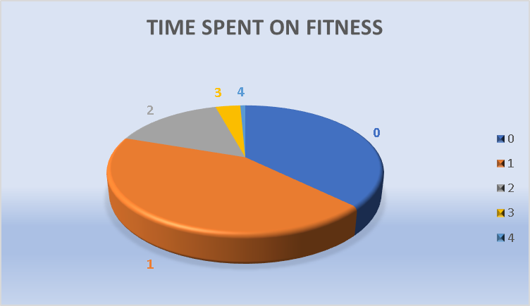

|  |  |
| --- | --- |
| TIME | STUDENTS INVOLVED IN FITNESS |
| 0 | 53 |
| 1 | 61 |
| 2 | 22 |
| 3 | 5 |
| 4 | 1 |

The given pie diagram shows the respective number of students took part in physical-activity.

The given pie diagram shows the time spent by students on physical activity.

2. The given bar graph compares the medium used by student for online classes

The given bar diagram shows that most of students preferred using smartphones and laptop rather than desktop and tablet.

3. Pie diagram compares the usage of social media among UG and PG.

UG:

Right end side of the pie diagram represents the respective social media platform used by the students.

98.24% of students used Instagram, followed by Whatsapp(93.23%), YouTube(69.17%).

PG:

Among the post graduate students the usage of Whatsapp was 56%, followed by Instagram and YouTube at 11%.

Conclusion: Usage of social media was found more to be in Under graduate students than Post graduate student.

4. Multiple bar diagram shows the usage of different social media platform for Stress busters.

Listening to music was most preferred by the students of UG and PG for stress busters compare to other activities.

5. Health issue among students.

The given pie diagram shows the ratio of students having issue during Covid19 period.

73% that is 103 students among 142 students were not having any sort of health issue. While 27 % that is 39 students among 142 students were facing health issue during Covid 19.

6. Experience of students during Covid19.

(1: Ver bad to 5: Excellent)

|  |  |
| --- | --- |
| **Rating** | **Frequency** |
| 1 | 23 |
| 2 | 45 |
| 3 | 49 |
| 4 | 19 |
| 5 | 6 |

Majority of the students experience was bad during the period of Covid19.

Chi-square test for independence

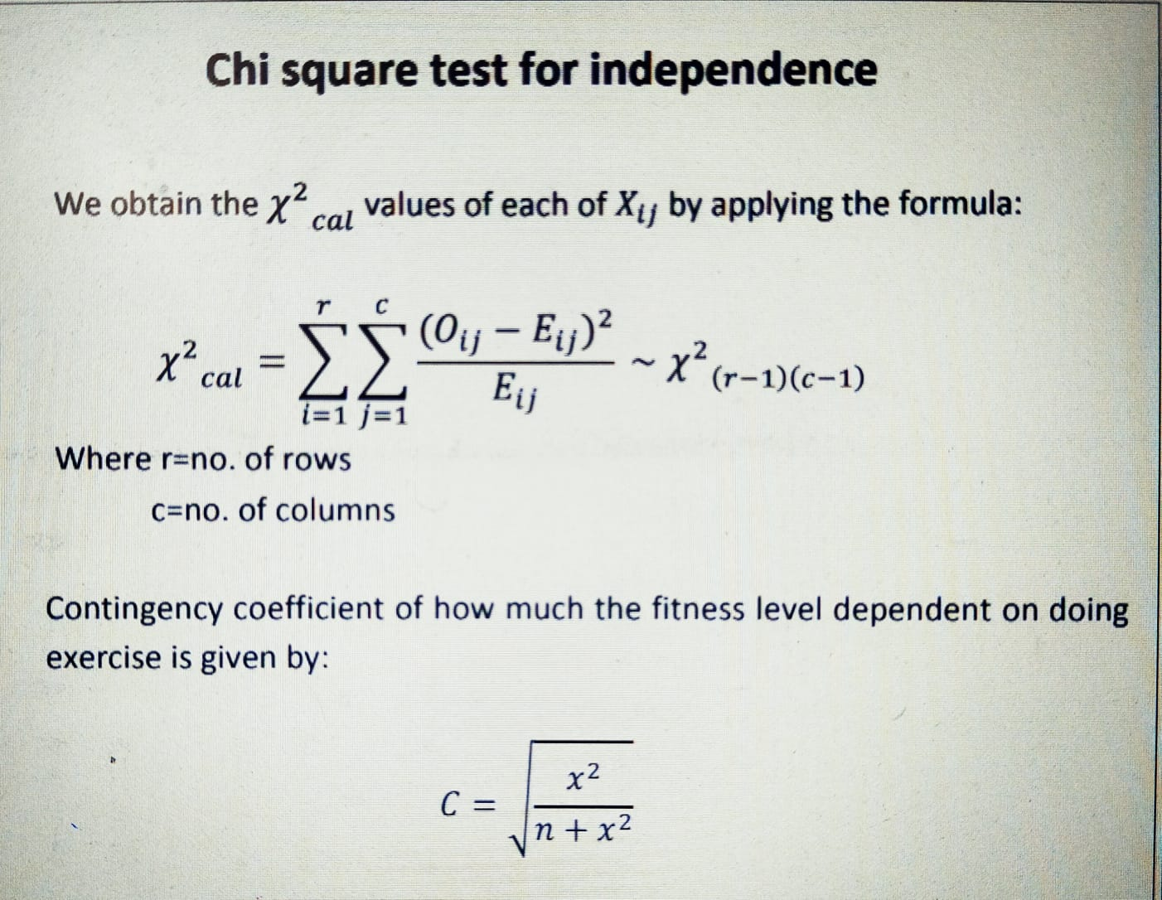

**1**. To check the independence of Stress buster on Student mental health.

HYPOTHESIS:

Ho : Stress buster is independent of students mental health.

H1 : Stress buster is dependent of students mental health.

|  |  |  |  |  |  |  |  |  |  |  |
| --- | --- | --- | --- | --- | --- | --- | --- | --- | --- | --- |
| OBSERVED  FREQUENCY | MUSIC | DANCE | Reading  Book | Webseries and  movies | Cooking | Studying | | ExERCISE | playing | online gaming |
| UG | 28 | 10 | 3 | 21 | 2 | 1 | | 7 | 10 | 7 |
| PG | 12 | 1 | 0 | 3 | 1 | 0 | | 6 | 3 | 2 |
| meditation | | | online surfing | | | | using social media | | | |
| 3 | | | 1 | | | | 18 | | | |
| 2 | | | 0 | | | | 0 | | | |

|  |  |  |  |  |  |  |  |  |  |  |  |  |  |  |
| --- | --- | --- | --- | --- | --- | --- | --- | --- | --- | --- | --- | --- | --- | --- |
| Expected  Frequency | Music | | Dance | | reading books | Webseries and movies | cooking | studying | | | exercise | | playing | online gaming |
| UG | 31.48 | 8.6595 | | | 2.361 | 18.893 | 2.361 | 0.78723 | | 10.2340 | | 10.234 | | 7.08510 |
| PG | 8.5106 | 2.340425 | | | 0.63829 | 5.10638 | 0.6382 | 0.212766 | | 2.76595 | | 2.76595 | | 1.91489 |
| meditation | | | | online surfing | | | | | using social media | | | | | |
| 3.936170213 | | | | 0.787234043 | | | | | 14.17021277 | | | | | |
| 1.0638298 | | | | 0.212766 | | | | | 3.8297872 | | | | | |

Inference:

Chi-square calculated : 16.25255

Chi-square tabulated : 19.6751

Chi-square calculated is less than Chi-square tabulated hence we donot reject the null hypothesis at 5% level of significance.

Hence there is no association between students mental health and Stress busters.

**2.** To find the association between online classes and students productivity related to studies.

Hypothesis:

Ho : Productivity is not associated (independent ) with time spent on online classes.

H1 : Productivity is associated (dependent ) with time spent on online classes

Time spent on online classes

|  |  |  |  |  |
| --- | --- | --- | --- | --- |
| Productive | (1-2) | (2-3) | (3-4) | more than 5 |
| yes | 14 | 21 | 31 | 15 |
| no | 13 | 7 | 25 | 16 |

Time spent on online classes

|  |  |  |  |  |
| --- | --- | --- | --- | --- |
| Expected frequency | (1-2) | (2-3) | (3-4) | More than 5 |
| yes | 15.40140845 | 15.97183099 | 31.94366197 | 17.68309859 |
| no | 11.59859155 | 12.02816901 | 24.05633803 | 13.31690141 |

|  |
| --- |
|  |

CONCLUSION:

Chi-square calculated : 4.9943

Chi-square tabulated : 7.81473

We do not reject the null hypothesis(Ho) at 5% level of significance. There is no association between productivity and time spent on online classes.

**3.** To find the association between health issue and physical activity.

Hypothesis:

Ho : Health issue is not associated with physical activity.

H1 : Health issue is associated with physical activity.

|  |  |  |
| --- | --- | --- |
| Health issue | Physical activites | |
| Yes | 10 | 29 |
| no | 26 | 77 |

|  |  |  |
| --- | --- | --- |
| Expected frequency | Physical activites | |
| yes | 9.887323944 | 29.11267606 |
| no | 26.11267606 | 76.88732394 |

Chi-square calculated : 0.002371

Chi-Square tabulated : 3.84146

Conclusion:

we do not reject H0 at 5% level of significance . Hence there is no association between health issue and physical activities.

**4.** To test weather online classes is independent of self study or not.

(To analyse growth of students on Educational perspective)

UG:

Hypothesis

Ho : ONLINE STUDIES IS INDEPENDENT OF SELF STUDY

H1 : ONLINE STUDY DEPENDENT ON SELFSTUDY

Self study

|  |  |  |  |  |  |  |
| --- | --- | --- | --- | --- | --- | --- |
| Online classes | 0 | 1 | 2 | 3 | 4 | 5 |
| 1-2 hours | 6 | 9 | 5 | 2 | 0 | 1 |
| 2-3 hours | 2 | 4 | 10 | 5 | 1 | 2 |
| 3-4 hours | 3 | 6 | 17 | 15 | 0 | 2 |
| more than 5 hours | 1 | 8 | 9 | 3 | 1 | 0 |

Expected frequency:

Self study

|  |  |  |  |  |  |  |
| --- | --- | --- | --- | --- | --- | --- |
| Online classes | 0 | 1 | 2 | 3 | 4 | 5 |
| 1-2 hours | 2.464285714 | 5.544642857 | 8.419642857 | 5.133928571 | 0.410714286 | 1.026785714 |
| 2-3 hours | 2.571428571 | 5.785714286 | 8.785714286 | 5.357142857 | 0.428571429 | 1.071428571 |
| 3-4 hours | 4.607142857 | 10.36607143 | 15.74107143 | 9.598214286 | 0.767857143 | 1.919642857 |
| more than 5 hours | 2.357142857 | 5.303571429 | 8.053571429 | 4.910714286 | 0.392857143 | 0.982142857 |

Chi-square calculated value: 24.6150829

Chi-square tabulated value : 24.9958

P VALUE : 0.055357679

Degree of freedom : 15

P VALUE > 0.05

WE DON’T REJECT THE NULL HYPOTHESIS. HENCE ONLINE STUDIES IS INDEPENDENT OF SELF STUDY

PG:

Hypothesis

Ho : ONLINE STUDIES IS INDEPENDENT OF SELF STUDY

H1 : ONLINE STUDY DEPENDENT ON SELFSTUDY

self study

|  |  |  |  |  |  |  |
| --- | --- | --- | --- | --- | --- | --- |
| Online classes | 0 | 1 | 2 | 3 | 4 | 5 |
| 1-2 hours | 1 | 1 | 1 | 0 | 1 | 0 |
| 2-3 hours | 1 | 3 | 3 | 1 | 0 | 0 |
| 3-4 hours | 0 | 8 | 8 | 1 | 0 | 1 |
| more than 5 hours | 0 | 4 | 4 | 1 | 0 | 0 |

Expected frequency:

Self study

|  |  |  |  |  |  |  |
| --- | --- | --- | --- | --- | --- | --- |
| Online classes | 0 | 1 | 2 | 3 | 4 | 5 |
| 1-2 hours | 0.2051 | 1.641 | 1.641 | 0.3076 | 0.1025 | 0.1025 |
| 2-3 hours | 0.4102 | 3.282 | 3.282 | 0.6153 | 0.2051 | 0.2051 |
| 3-4 hours | 0.923 | 7.3846 | 7.3846 | 1.3846 | 0.4615 | 0.4615 |
| more than 5 hours | 0.4615 | 3.6923 | 3.6923 | 0.6923 | 0.2307 | 0.2307 |

Chi-square calculated: 16.73065

Chi-square tabulated : 24.9958

P value: 0.33522

Degree of freedom: 15

Conclusion:

HENCE CALCULATED IS LESS THAN TABULATED SO WE DONOT REJECT THE NULL HYPOTHESIS. Hence there is no association between online classes and self study.

**5** .To find the association between the students productivity and self study

Hypothesis:

Ho: Time spent on self study is independent of students productivity.

H1: Time spent on self study is dependent of students productivity

PRODUCTIVE

|  |  |  |
| --- | --- | --- |
| TIME SPENT (Self-Studies) | YES | no |
| YES | 75 | 53 |
| no | 6 | 7 |

EXPECTED FREQUENCY:

PRODUCTIVE

|  |  |  |
| --- | --- | --- |
| TIME SPENT | YES | NO |
| YES | 73.5319 | 54.468 |
| NO | 7.468 | 5.5319 |

Chi-square calculated : 0.74706

Chi-square Tabulated: 3.84146

P value : 0.387409

Degree of freedom: 1

Conclusion:

P VALUE IS GREATER THAN 0.05(level of significance). HENCE WE DONOT REJECT THE NULL HYPOTHESIS

Therefore time spent on self study is independent of the productivity of students.

**6.** To find the association between the students productivity and Fitness.

Hypothesis:

Ho : Time spent on Fitness (Physical activity)is independent of students productivity.

H1 : Time spent on Fitness (Physical activity)is dependent of students productivity.

PRODUCTIVITY

|  |  |  |
| --- | --- | --- |
| PHYSICAL ACTIVITY | YES | NO |
| YES | 54 | 29 |
| NO | 23 | 30 |

EXPECTED FREQUENCY TABLE:

PRODUCTIVITY

|  |  |  |
| --- | --- | --- |
| PHYSICAL ACTIVITY | YES | NO |
| YES | 46.9926 | 36.0073 |
| NO | 30.0073 | 22.9926 |

Chi-square calculated : 6.18057

Chi-square Tabulated: 3.84146

P value : 0.012916

Degree of freedom: 1

Conclusion:

P VALUE IS GREATER THAN 0.05 (Level of significance)

WE DONOT REJECT THE NULL HYPOTHESIS. There is no association between productivity and time spent on physical activity.

LOGISTIC REGRESSION

HYPOTHESIS:

Ho : β=0 against H1 : β ≠ 0

Y = Productive

X1 = Time spent on self-study.

X2 = Time spent on Fitness.

X3 = Time spent on sleep.

The Regression model is defined as:

Y = X1 + X2 + X3

Coefficients:

Intercept: 0.06619

X2: -0.08274

X3 (5-6 hours): 0.58207

X3 (7-8 hours): 0.62397

X3 (9-10 hours): 0.5390

Degrees of Freedom: 141 Total (i.e. Null); 137 Residual

Null Deviance: 34.8

Residual Deviance: 32.16

AIC: 204.1

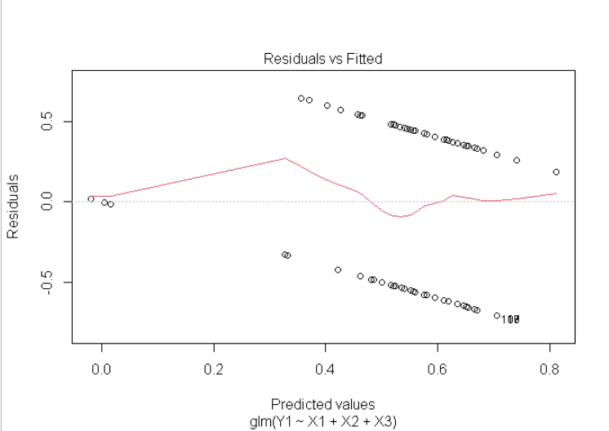

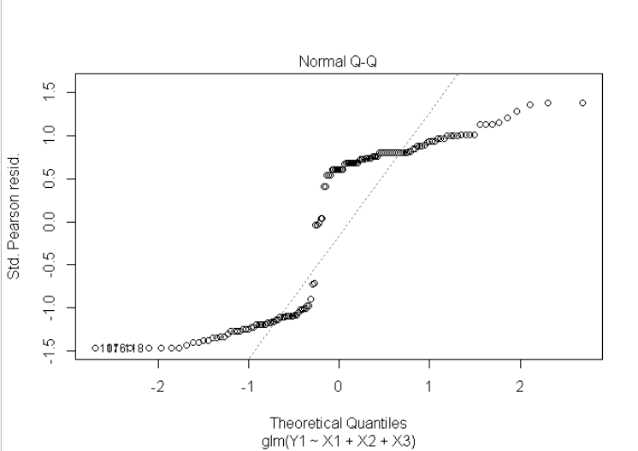

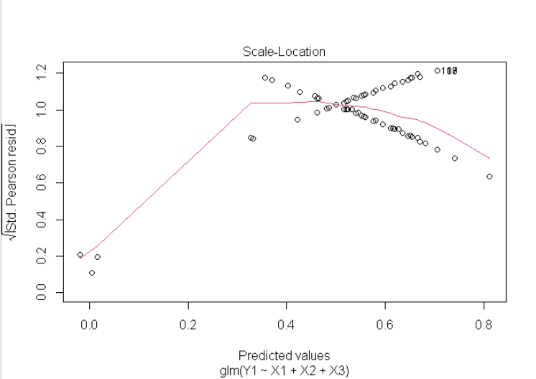

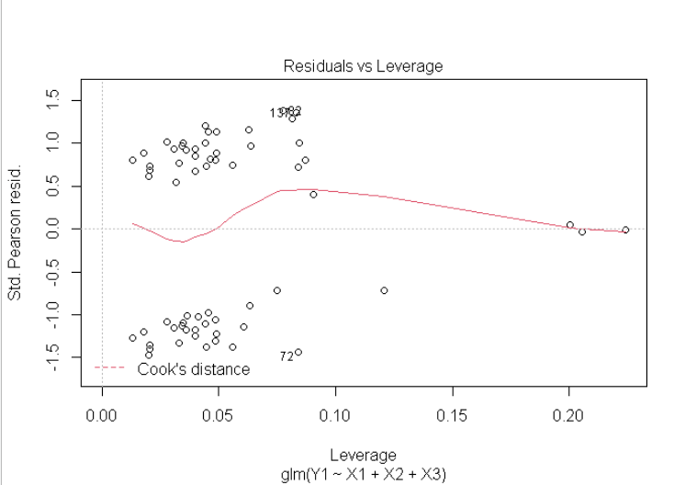

**QUESTIONAIRE**

1. In which year?
2. AGE.
3. TIME SPENT ON ONLINE CLASSES. (IN HOURS)
4. RATING OF ONLINE CLASS EXPERIENCE
5. MEDIUM FOR ONLINE CLASS
6. TIME SPENT ON SELF-STUDY ( IN HOURS
7. TIME SPENT ON FITNESS ( IN HOURS )
8. TIME SPENT ON SLEEP
9. TIME SPENT ON SOCIAL MEDIA PLATFORM (IN HOURS)
10. PREFERRED SOCIAL MEDIA PLATFORM
11. TIME SPENT ON WATCHING TELEVISION ( IN HOURS)
12. NUMBER OF MEALS PER DAY
13. CHANGE IN YOUR WEIGHT
14. HEALTH ISSUE DURING LOCKDOWN
15. STRESS BUSTERS
16. Did you find yourself productive during the Covid 19 lockdown-period.
17. Rate the impact on your studies during the period of covid 19 ( 1: very bad and 5 : excellent )

(Data collected was “Primary data”.

Source : Online google form.)

**REFERENCE**